**GIT Assignment – 3**

**● Create a git working directory, with the following branches ○ Develop ○ F1 ○ f2**

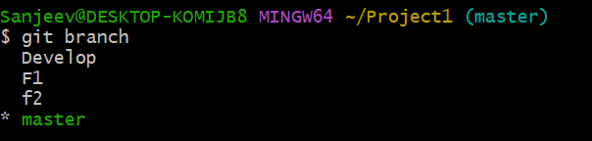

**● In the master branch, commit main.txt file**

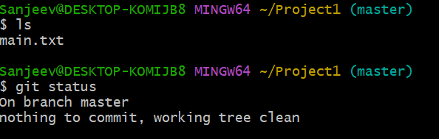

**● Put develop.txt in develop branch, f1.txt and f2.txt in f1 and f2 respectively**



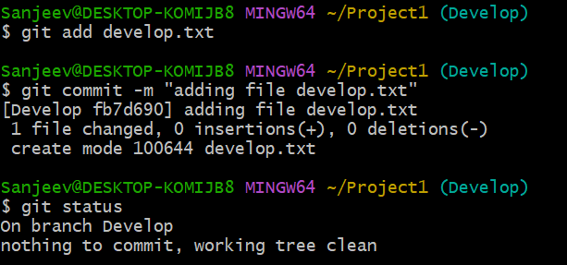

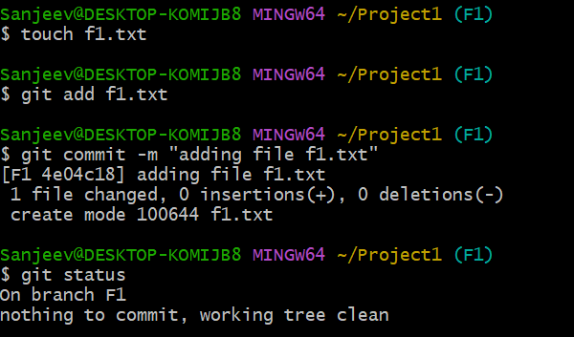

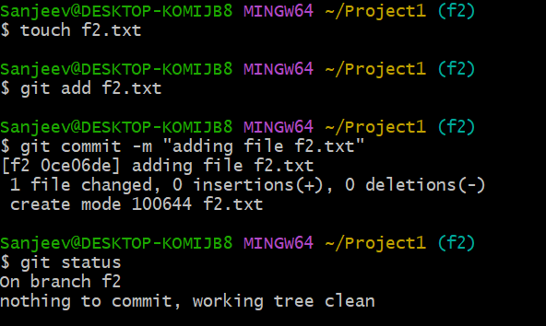

**● Push all these branches to github**

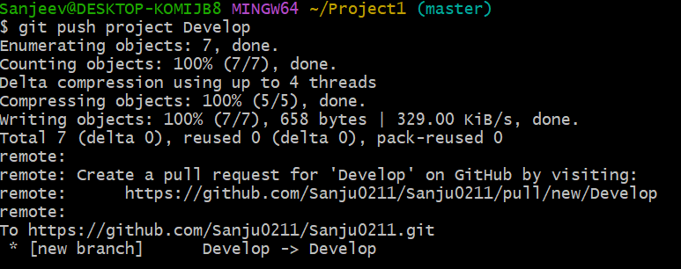

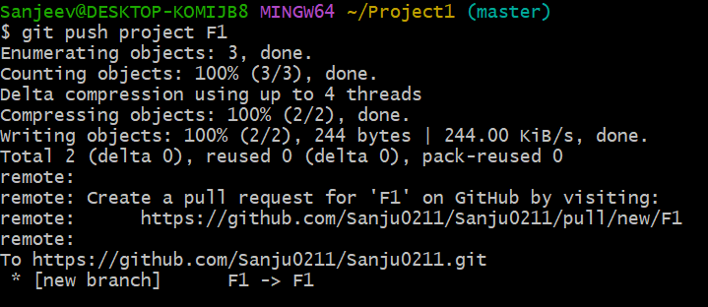

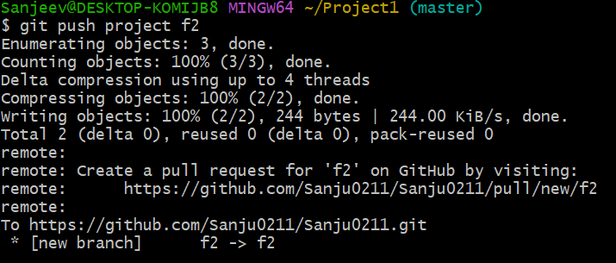

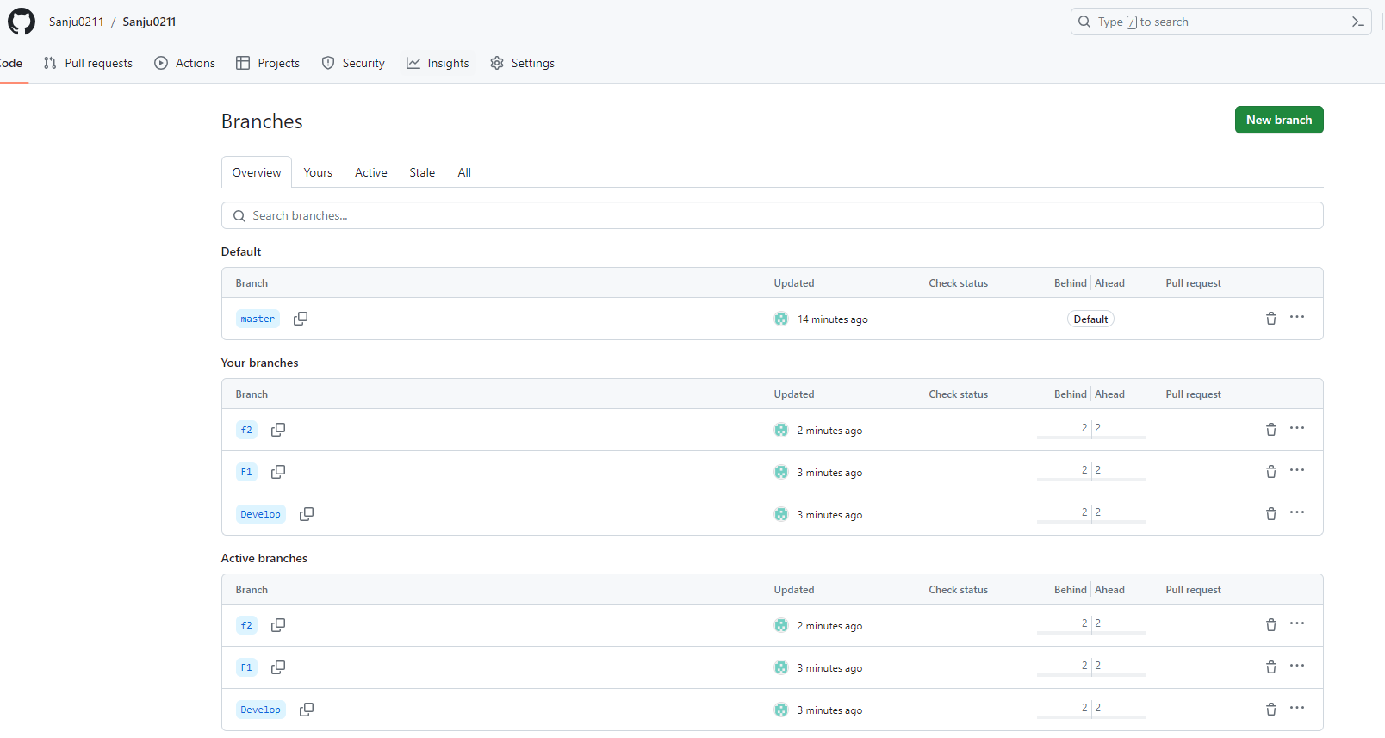

**● On local delete f2 branch**

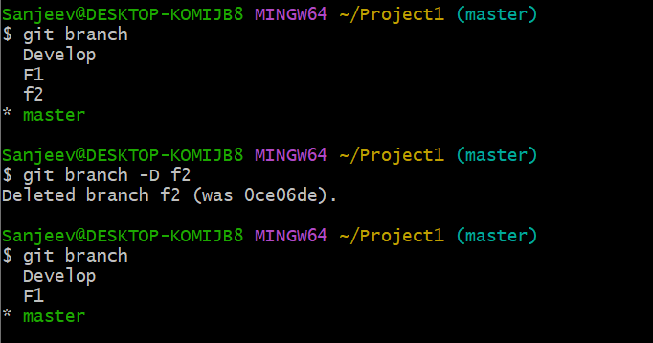

**● Delete the same branch on github as well**

